Sentiment analysis using R

1. Required R packages are

library(twitteR)

library(ROAuth)

library(plyr)

library(dplyr)

library(stringr)

library(ggplot2)

2. Pre-requisite: Twitter authorization key should be present on your account.

3. Steps :

1. Login to twitter online and gather the required data.
2. Save to a csv file for further use
3. Get the list of positive and negative words from google to a file
4. Compare the words in the tweets to the words present in the positive and negative file and then provide scores according to the matching.
5. Show the scores in the form of histogram

4. The below histogram shows the score between -4 to 4.

0 to 4 are positive words in a tweet.

-4 to 0 are negative words in a tweet.

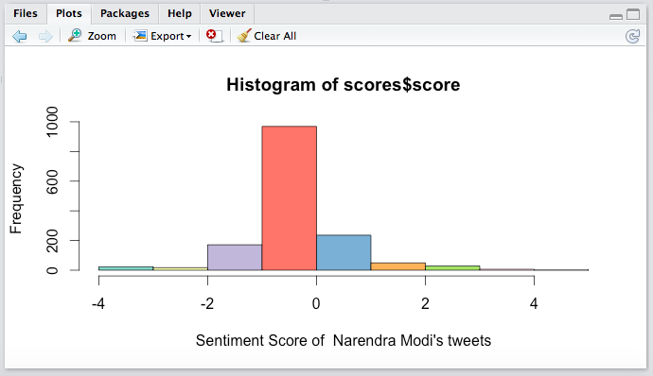

Word Cloud:

